

**7th Annual Keystone Central Foundation**

Night Flight

**Golf Tournament**

To register, please complete the attached form or visit [www.kcfoundation.com](http://www.kcfoundation.com).

**Registration Form**

**Golfer Registration Includes:**

* Pre-Tournament Buffet Dinner
* Complimentary Keg Beer
* Door Prizes
* Glow-in-the Dark Golf Balls

Tournament Format:

* Four Man Scramble
* Best Ball
* 9-Holes
* **NO CARTS WILL BE USED**
* **COURSE WILL BE ADJUSTED FOR NIGHT PLAY**

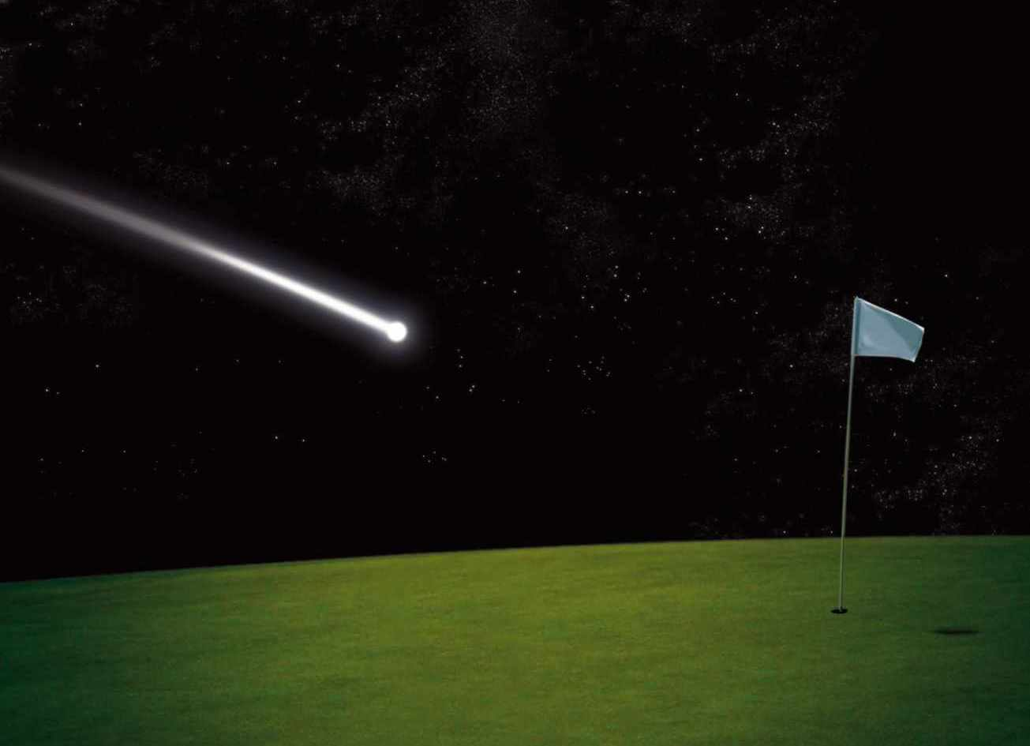

Please return this portion with your payment by July 30, 2022

**Company/Team Name (if applicable:)** ________________________________________________________________________

**Primary Contact Person:** ____________________________________________________________________________________

**Email:** ____________________________________________ **Phone:** ________________________________________

**Address:** __________________________________________________________________________________________________

Type of Registration: *(please check all that apply)*

___ Golfer Registration: ($80.00 each or $320.00 per foursome – includes dinner)

**Names of Golfers in Foursome:**

**1.** ____________________________________________ **3.** ____________________________________________

**2.** ____________________________________________ **4.** ____________________________________________

___ Dinner and Auction Tickets Only: ($25.00 each)

**Total Number of Tickets Requested: _______**

**Please make checks payable to: *Keystone Central Foundation* and send to PO Box 565, Lock Haven, PA 17745 and return by July 30, 2022 OR pay by credit card at** [**www.kcfoundation**](http://www.kcfoundation)**.**

**Additional Games**

**Putting Contest**

**50/50**

**Longest Drive**

**Closest to the Pin**

**Mulligans**

**Door Prizes**

The Schedule

6:00 PM – 7:30 PM | Registration Begins

Clinton Country Club, Mill Hall, PA

6:00 PM | Buffet Dinner & Auction Items Open

7:30 PM | Team Meeting

7:45 PM | Tee Off

9:30 PM | Last Golfers In, Awards, and Raffle